Guide to using Church Update
To access Church Update please use the link on our webpage www.baptist.org.uk/churchupdate
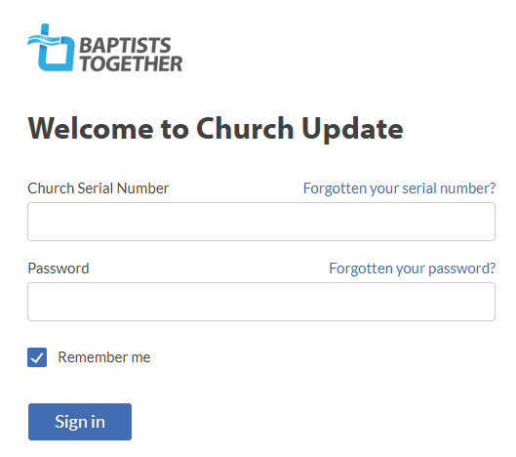
Enter your serial number and password and then click ‘Sign in’

Once you have logged in you can change your password – use the link on the left-hand side.

Logging in takes you to the Church Info section.
- If anything needs amending use the relevant ‘Edit’ button on the right, make the change and click Confirm (or Cancel to exit without making any changes)
- Please note that you are unable to edit the name of your church. If this is incorrect, please email our Database Administrator (dmoore@baptist.org.uk)
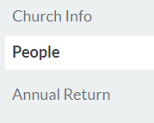
Now move to the People section using the link on the left-hand side.
This is where you tell us about changes to people in key roles. The roles we need to know about are as follows:
Minister (including Lay Pastor and Minister-in-Training)
Church Secretary/Main Contact
Church Treasurer
Safeguarding Trustee
Designated Person for Safeguarding (DPS)
Children’s Worker, Families Worker, Youth Worker (paid roles only)
[For an explanation of what we mean by these roles please see page 3 of this document].
To view the information, we hold about each person click under their name.
- To edit their name, their address or other contact details. Please use the relevant ‘Edit’ button on the right, make the change and click Confirm (or Cancel to exit without making any changes)
- To let us know that one of these people is not in the role listed Click ‘Edit Role’ and then ‘No longer in this role’. You will be asked to provide the date when the role ended. You are also asked if this person is taking on another role – click ‘Yes’ or ‘No’ as appropriate. If ‘Yes’ you will then be taken to the ‘Add Role’ option (see below)
- When the Church Secretary/Main contact is being changed you need to add the new person BEFORE you can remove the former Church Secretary/Main contact.
- To let us know that one of the people listed has a new role, click ‘Edit Role’ and ‘Add New Role’. Choose the appropriate role from the Dropdown list and give their start-date
- To go back to the main people page, click the arrow next to the person’s name
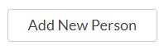
- To add someone who is not currently listed click ‘Add New Person’; fill in the relevant fields and make sure you add their role(s)
When finished click ‘Confirm’.
To cancel click ‘Cancel’ under ‘Add new person’ (top left)

Annual Returns
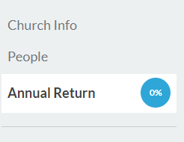
In “Annual Returns” season (normally December and January) you will have the option to complete your Annual Return. Access this from the menu on the left-had side.

On this page you will be told how much you have completed and how long you have before the system closes.
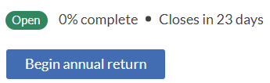
Also on this page you are able to view the statistics we hold from previous years.
Click Begin annual return to get started!
If you have started and saved this, the box will say Continue Annual Return
There are two sections of figures - Membership and Attendance – which you need to work through in this order. You should be able to view the previous year’ figures and there are pop-up boxes which explain what we are looking for.
Follow the instructions on the page but make sure you complete every box in both sections.
The third stage is the ‘Review’ stage which given you the opportunity to review (and edit if necessary) all the information we hold for your church.
At the bottom of the page is the Submit Annual Return button which you do need to click in order to submit the return to us.

Roles in Church Update

Church Secretary/Main Contact:
This should be the main (admin) contact person for your church (usually the Church Secretary) irrespective of their actual title.
You must have someone listed in this role in order to submit your return.

Church Treasurer
The key person to contact regarding church finances. Please ensure you list someone in this role even if it is ‘The Church Treasurer’ at the church address

Minister
Lay Pastor
Minister-in-Training
Non-Baptist Minister
This is the person/people who have been formally appointed as Ministers or lay-pastors of your church. If your Minister is from a different denomination (because you are an Ecumenical Church) please use ‘Non-Baptist Minister’

Safeguarding Trustee
The member of your Trustee Group (e.g. Diaconate) with overall responsibility for Safeguarding issues in your church.

DPS (Designated Person for Safeguarding)
The person (or people) who takes the lead on Safeguarding for the church.

Children’s Worker
Families Worker
Youth Worker
Please note that we only want to know about those people appointed to one or more of these roles in a PAID capacity. If someone is employed in a role which covers more than one of these (e.g. Children and Families Worker) please add them in both (or all three) of these roles.

Please note that people in your church who are in other roles (or are volunteer workers) are no less important – it’s just that we don’t currently need to know about them. Under Data Protection legislation we should only collect personal information we actually need.

To notify us of changes to DBS Verifiers please continue to use the online form at www.baptist.org.uk/dbsverifierchanges

